**1.Total Revenue**

select sum(total_price) as Total_Revenue from pizza_sales;

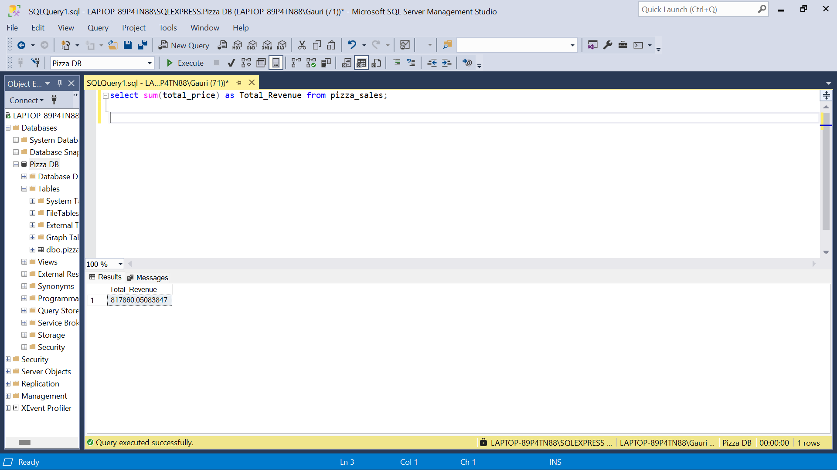

**2. Average Order Value**

select sum(total_price)/count(distinct order_id) as Avg_Order_Value from pizza_sales;

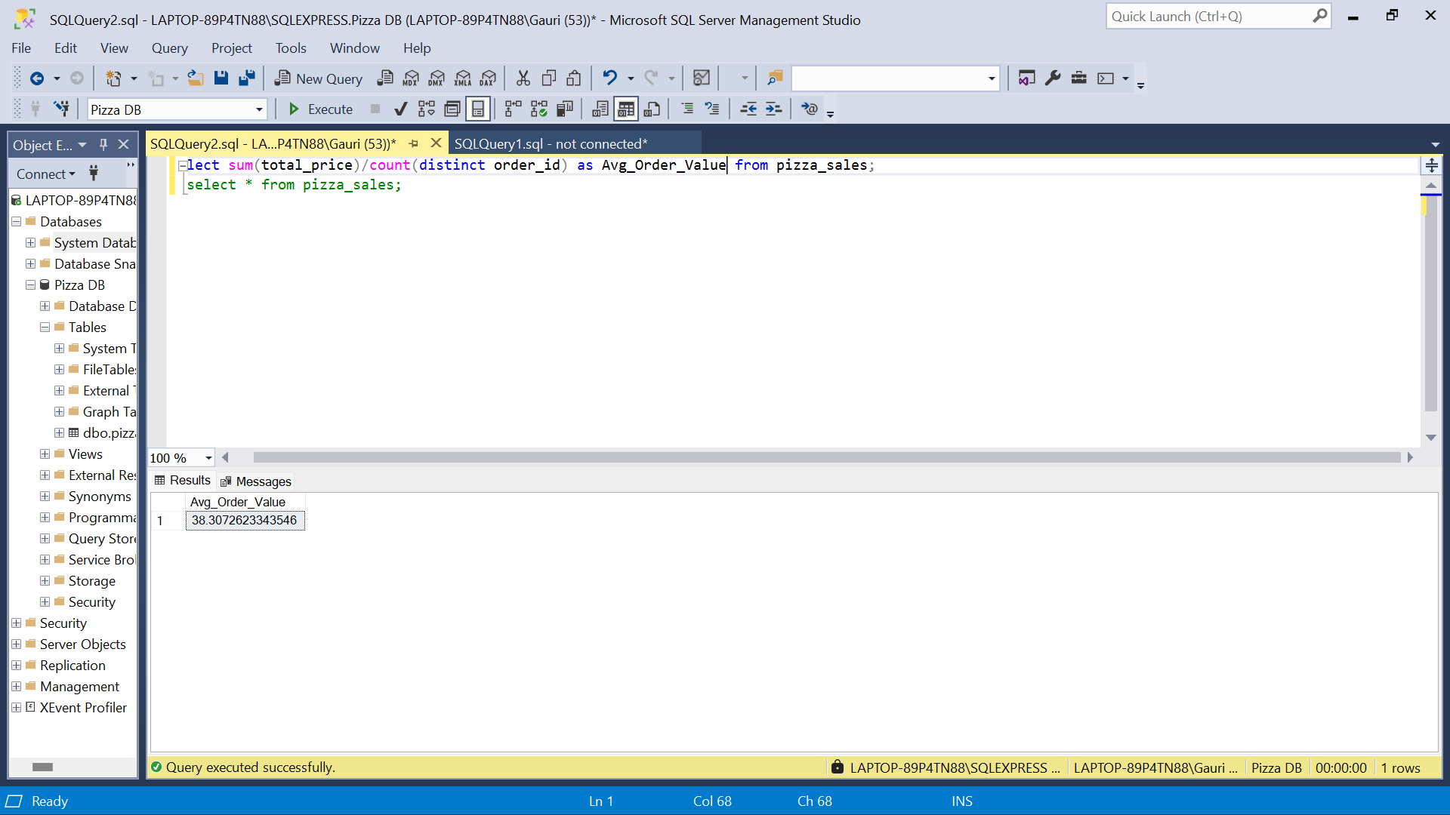

**3. Total Pizzas Sold**

select sum(quantity) as Total_Pizza_Sold from pizza_sales;

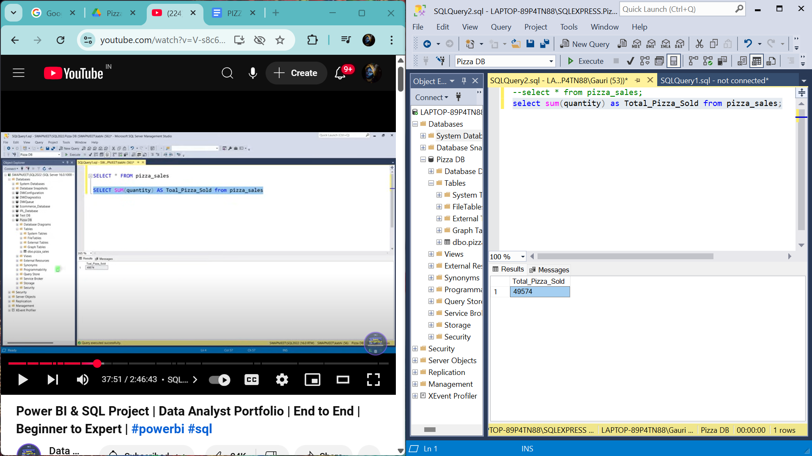

**4. Total Orders**

select count(distinct order_id) as Total_orders from pizza_sales;

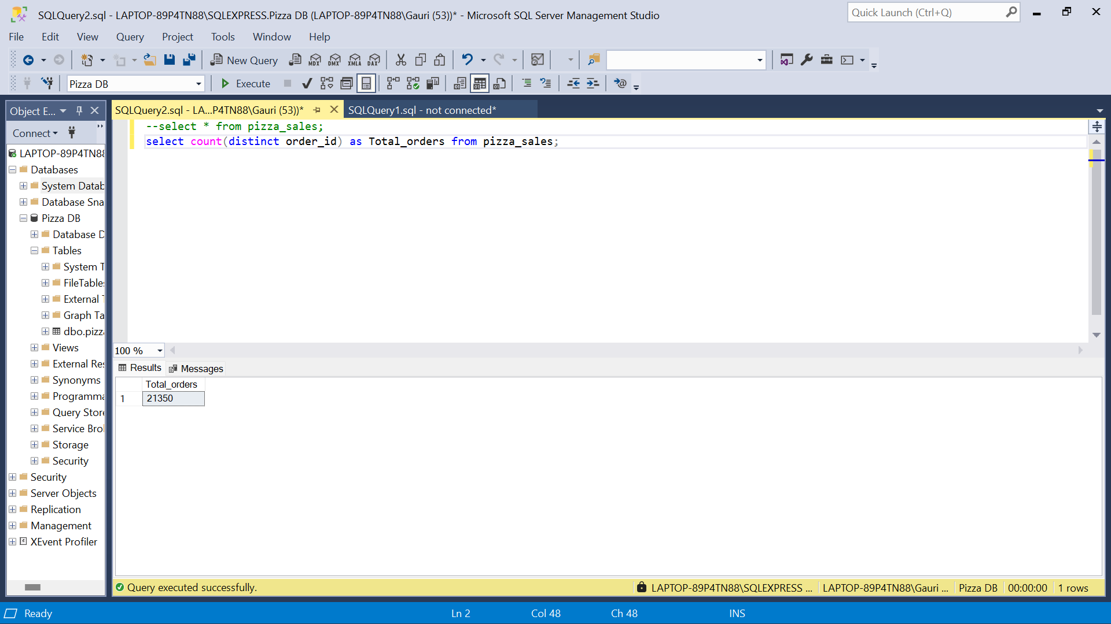

**5. Average Pizzas Per Order**

select cast(cast(sum(quantity) as decimal(10,2)) /

cast(COUNT(distinct order_id) as decimal(10,2)) as decimal(10,2))

as Avg_Pizzas_Per_order from pizza_sales;

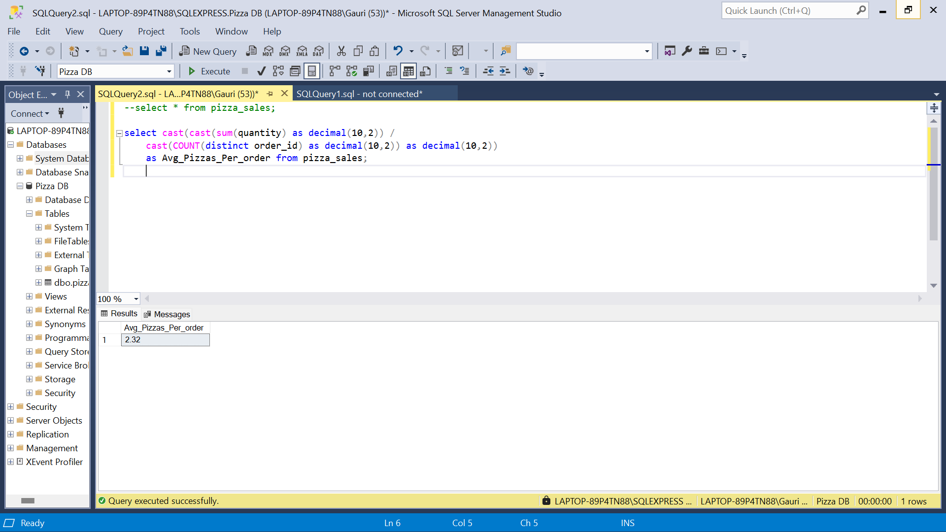

**B. Daily Trend for Total Orders**

SELECT

DATENAME(WEEKDAY, order_date) AS order_day,

COUNT(DISTINCT order_id) AS Total_orders

FROM

pizza_sales

GROUP BY

DATENAME(WEEKDAY, order_date);

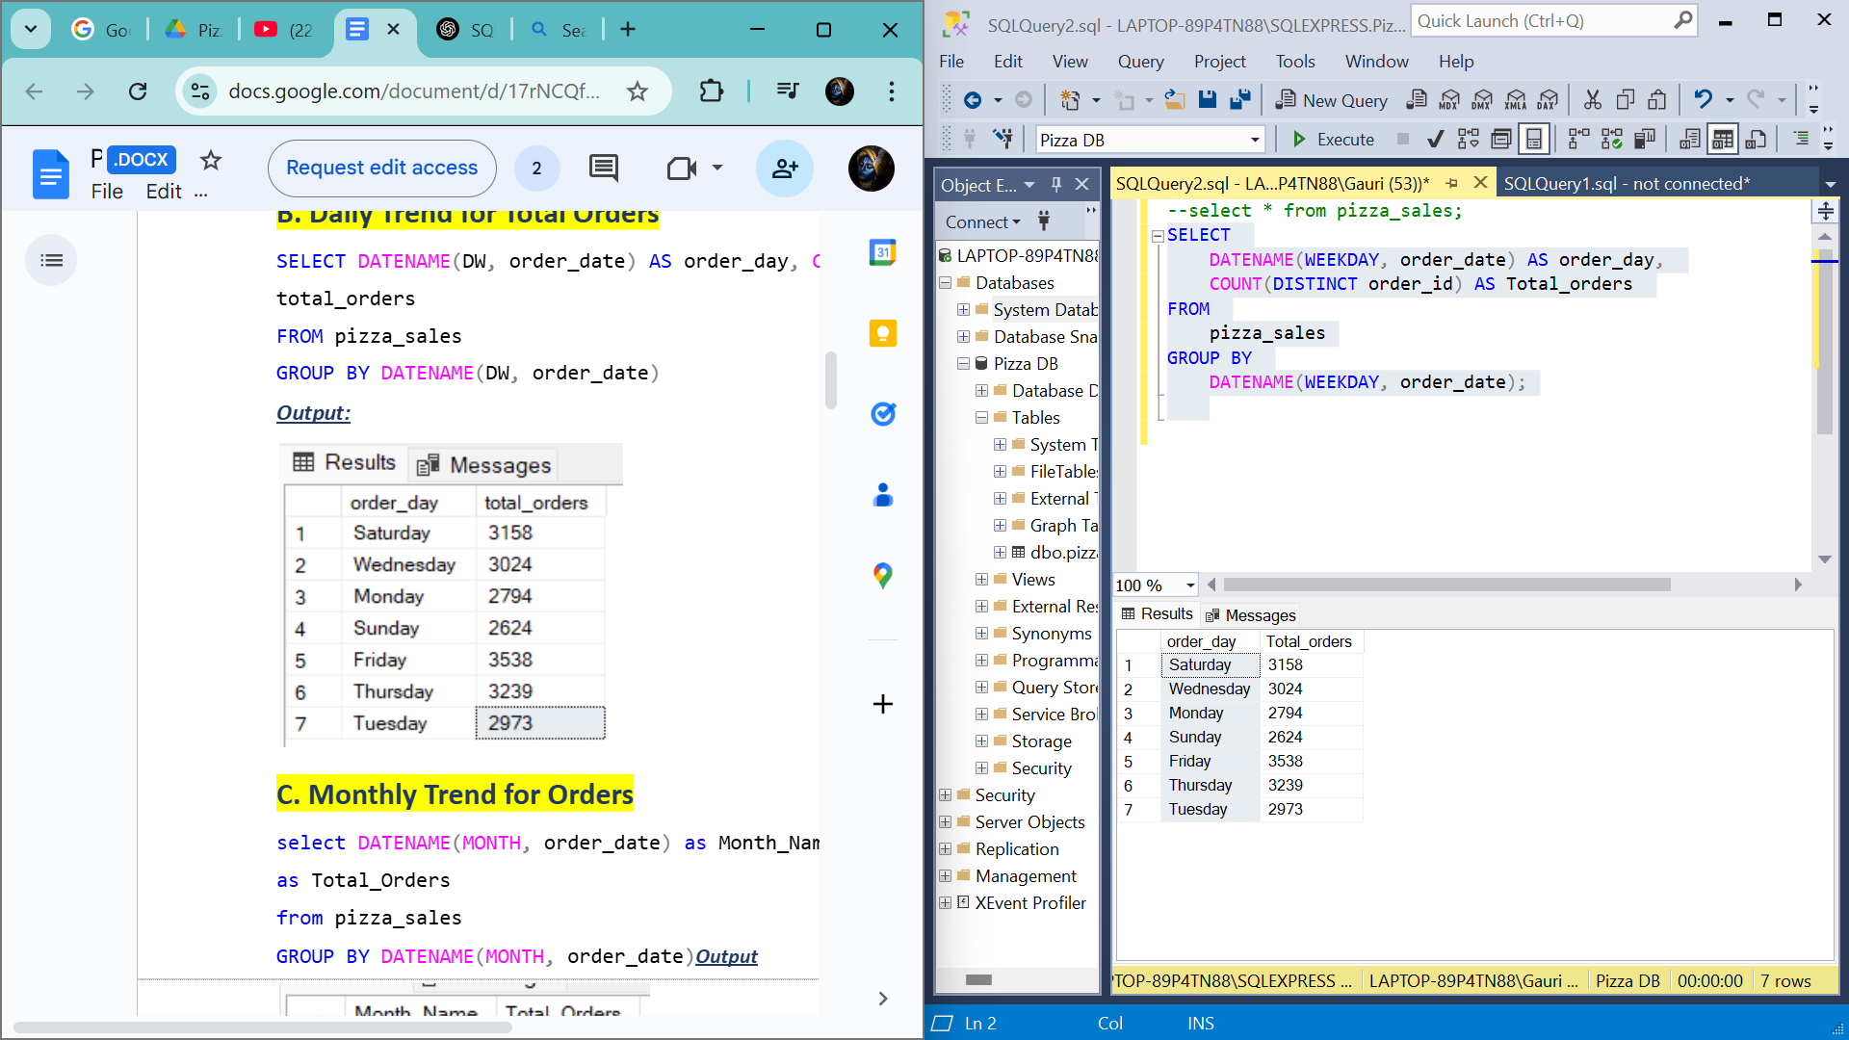

**C. Monthly Trend for Orders**

select datename(Month, order_date) as Month_name, COUNT(Distinct order_id) as Total_Orders

from pizza_sales

group by datename(Month, order_date)

order by Total_Orders DESC;

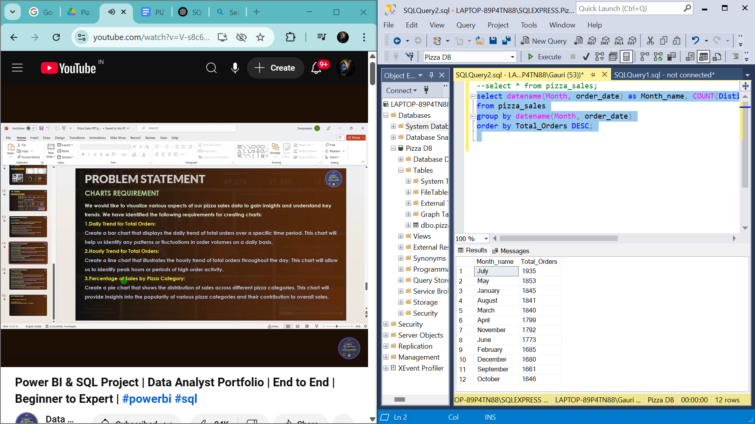

**D. % of Sales by Pizza Category**

select pizza_category,

cast(sum(total_price) as decimal(10,2)) as Total_Revenue,

cast(sum(total_price)*100/ (select sum(total_price) from pizza_sales) as decimal(10,2)) as PCT

from pizza_sales

group by pizza_category;

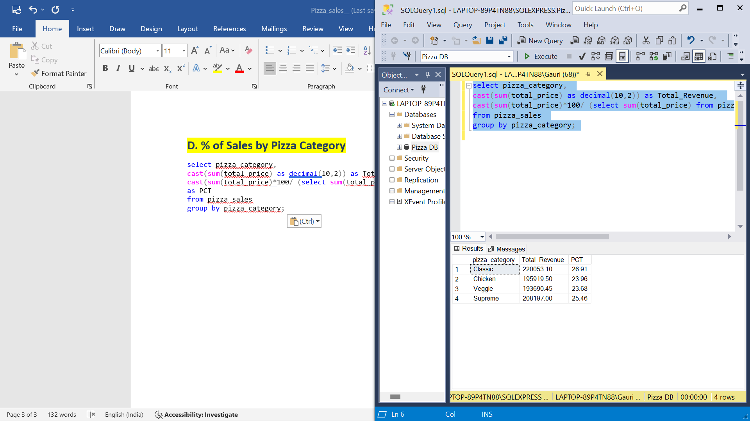

**E. % of Sales by Pizza Size**

select pizza_size, cast(sum(total_price) as decimal(10,2)) as Total_revenue,

cast(sum(total_price)*100 / (select sum(total_price) from pizza_sales) as decimal(10,2)) as PCT

from pizza_sales

group by pizza_size

order by pizza_size;

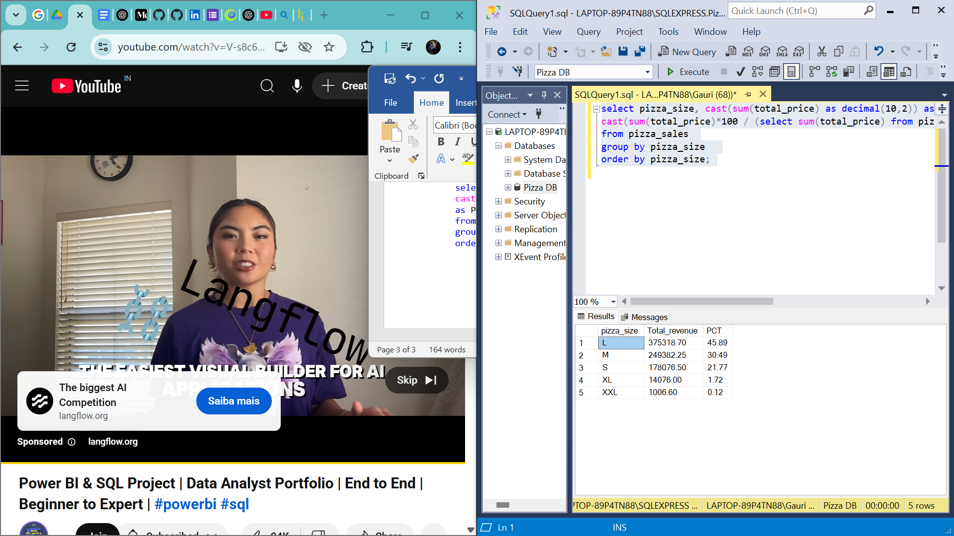

**F. Total Pizzas Sold by Pizza Category**

select pizza_category, sum(quantity) as Total_Quantity

from pizza_sales

group by pizza_category

order by Total_Quantity desc;

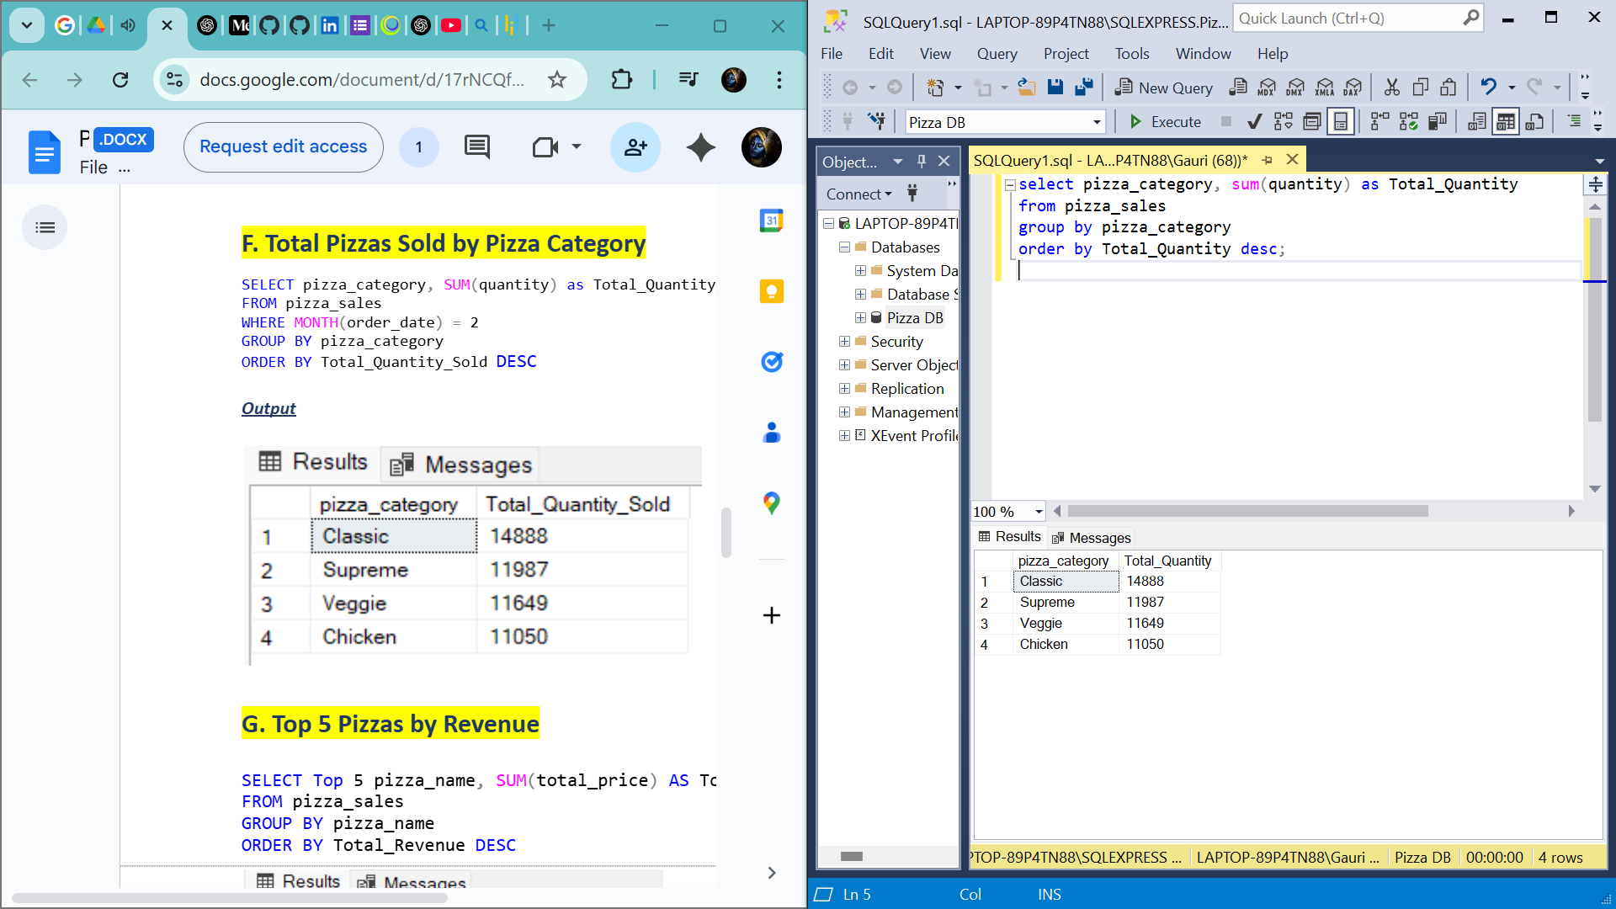

**G. Top 5 Pizzas by Revenue**

select top 5 pizza_name, sum(total_price) as Total_Revenue

from pizza_sales

group by pizza_name

order by Total_Revenue desc;

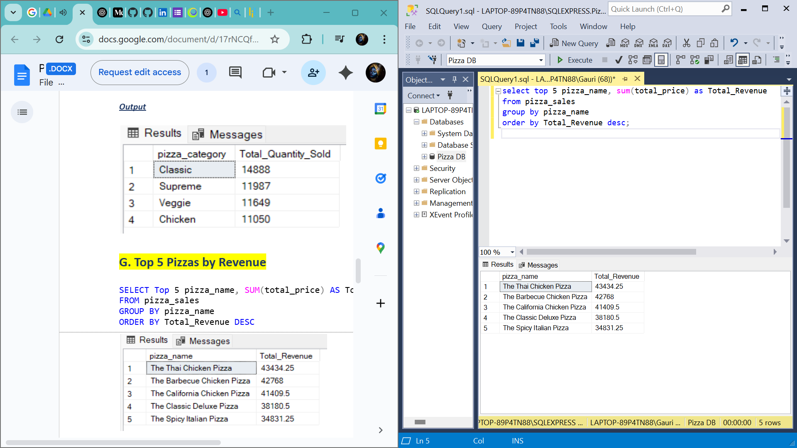

**H. Bottom 5 Pizzas by Revenue**

select top 5 pizza_name, sum(total_price) as Total_Revenue

from pizza_sales

group by pizza_name

order by Total_Revenue asc;

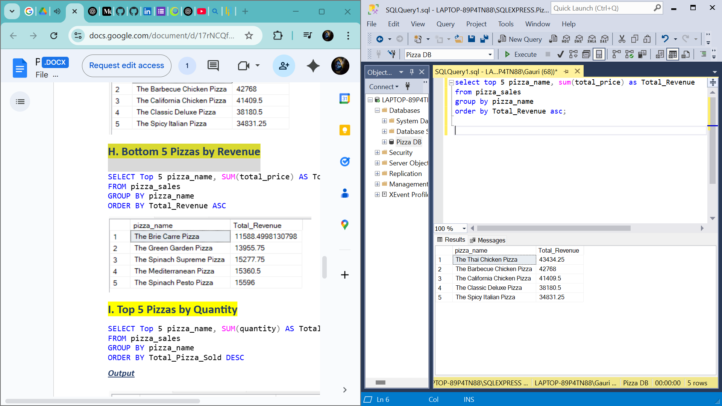

1. **Top 5 Pizzas by Quantity**

select top 5 pizza_name, sum(quantity) as Quantity

from pizza_sales

group by pizza_name

order by Quantity desc;

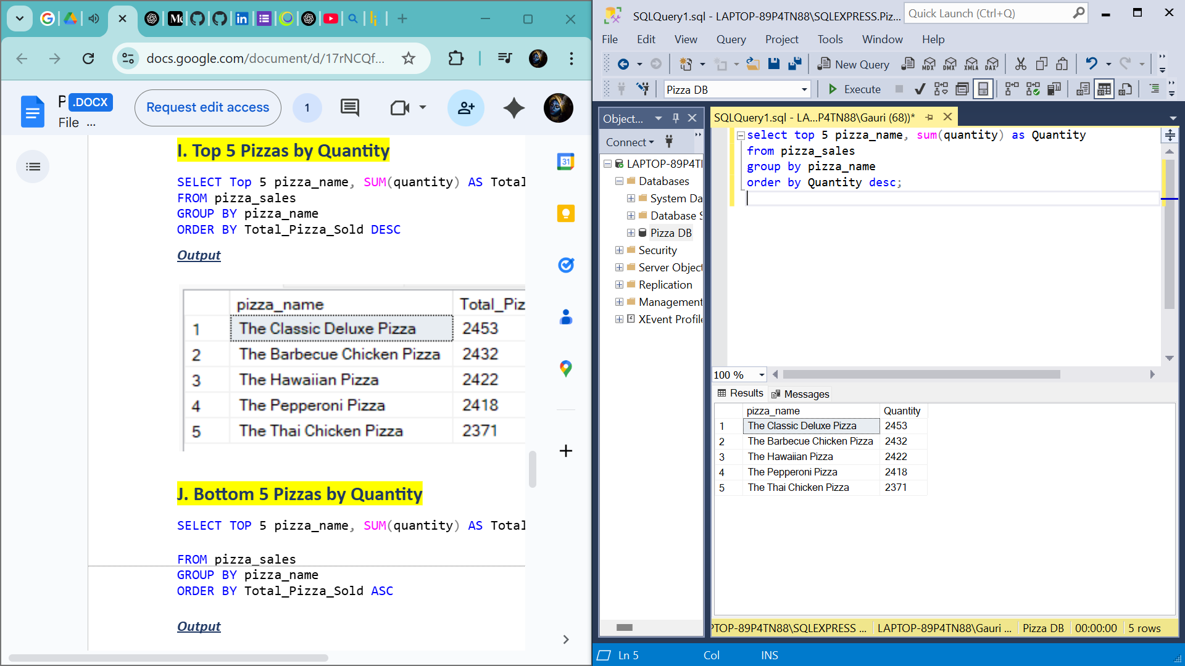

**J. Bottom 5 Pizzas by Quantity**

select top 5 pizza_name, sum(quantity) as Quantity

from pizza_sales

group by pizza_name

order by Quantity Asc;

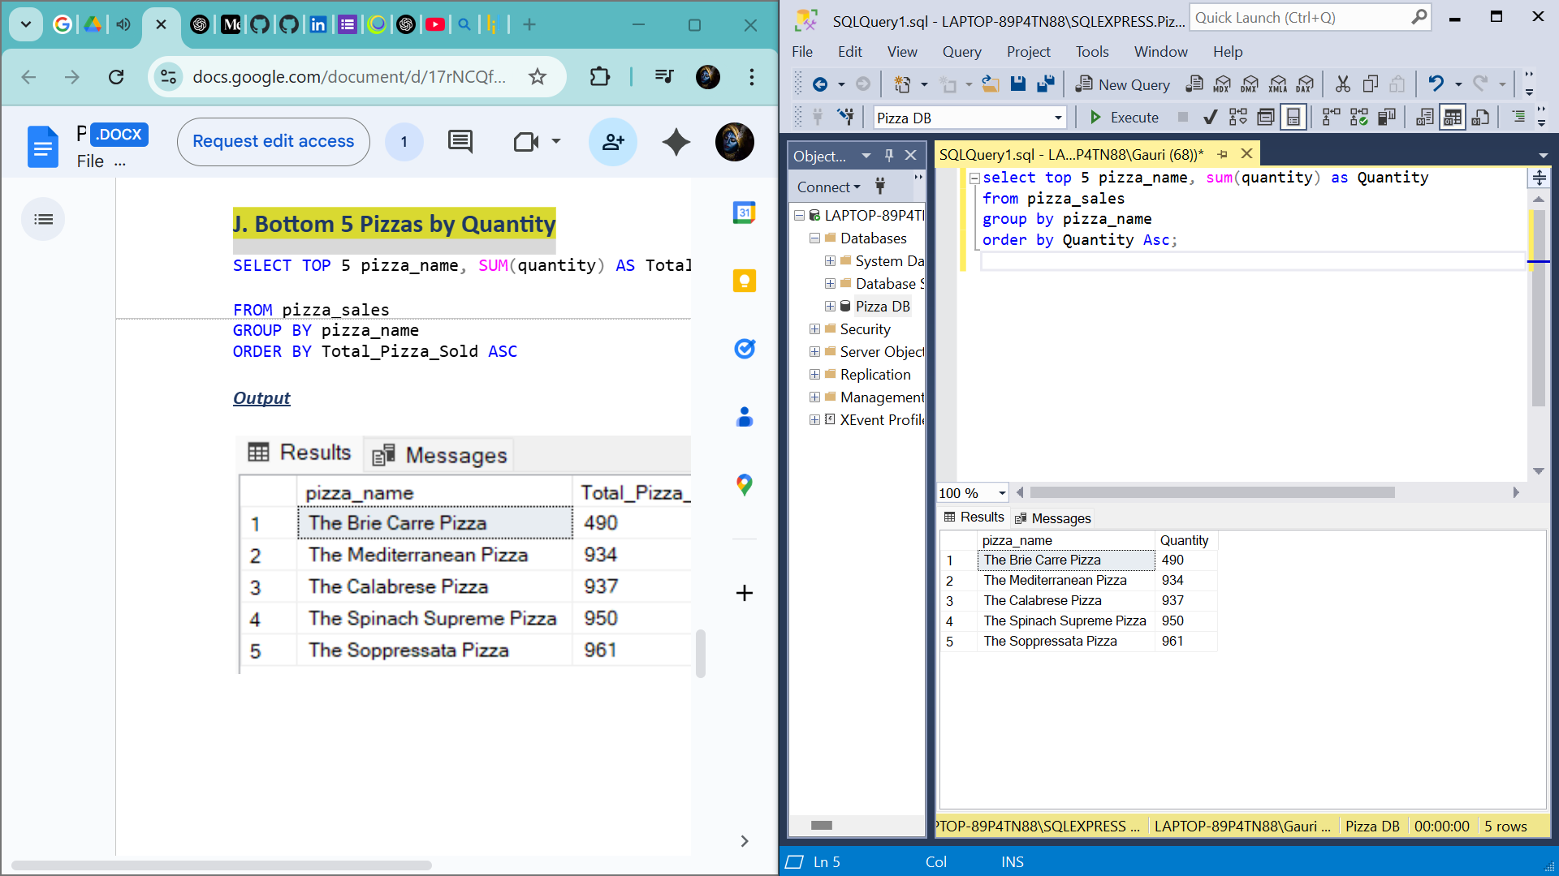

**K. Top 5 Pizzas by Total Orders**

SELECT Top 5 pizza_name, COUNT(DISTINCT order_id) AS Total_Orders

FROM pizza_sales

GROUP BY pizza_name

ORDER BY Total_Orders DESC;

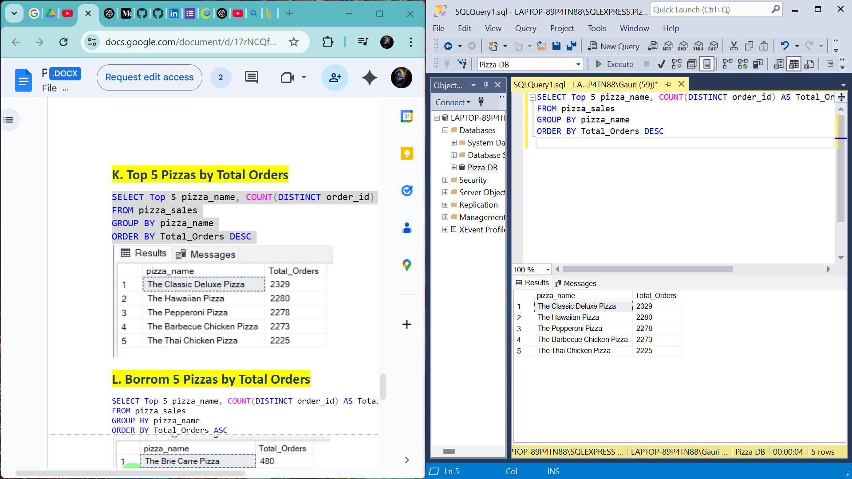

**L. Borrom 5 Pizzas by Total Orders**

SELECT Top 5 pizza_name, COUNT(DISTINCT order_id) AS Total_Orders

FROM pizza_sales

GROUP BY pizza_name

ORDER BY Total_Orders ASC

